Project Design Phase-II
Technology Stack (Architecture & Stack)

Date | 30 September 2026
Team ID | SWTID-2026-1259
Project Name | Streamlining IT Procurement: Automating Standard Laptop Orders with Flow Designer
Maximum Marks | 4 Marks

Technical Architecture:
The Deliverable shall include the architectural diagram as below and the information as per the table1 & table 2
Architecture: Automated standard laptop ordering and configuration with ServiceNow Flow Designer
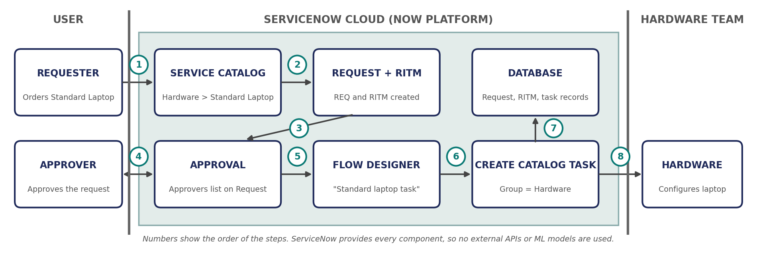

Table-1 : Components & Technologies:
S.No | Component | Description | Technology
 | User Interface | Requester orders the Standard Laptop from the Service Catalog (Hardware category); approver and Hardware team work on the Request, Requested Item and Catalog Task forms | ServiceNow Service Catalog and Now Platform UI
 | Application Logic-1 | Flow "Standard laptop task" starts from a Service Catalog trigger (Application: Global, Run As: System User) | ServiceNow Flow Designer
 | Application Logic-2 | "Create Catalog Task" action uses the Requested Item from the trigger and sets short description, description ("Laptop needs to Configured"), Assignment group (Hardware) and Approval (Approved) | Flow Designer action (ServiceNow Core: Create Catalog Task)
 | Application Logic-3 | Request approval by the approver, and assignment of the flow to the Standard Laptop item through the Process Engine tab | ServiceNow Approvals; Maintain Items (Catalog Item > Process Engine)
 | Database | Stores the Request, Requested Item and Catalog Task records created by the order | ServiceNow platform database (sc_request, sc_req_item, sc_task tables)
 | Cloud Database | Data is held in the ServiceNow cloud instance; no separate database service is used | ServiceNow cloud instance
 | File Storage | No separate file storage is needed for this project | Not applicable (ServiceNow built-in attachments, if ever needed)
 | External API-1 | Not used; all steps run inside ServiceNow | Not applicable
 | External API-2 | Not used; all steps run inside ServiceNow | Not applicable
 | Machine Learning Model | Not used; the solution is rule-based automation | Not applicable
 | Infrastructure (Server / Cloud) | Application deployment on Cloud  Local Server Configuration: Not required  Cloud Server Configuration: ServiceNow-hosted instance; flow and catalog item built in the Global application | ServiceNow Cloud (Now Platform)

Table-2: Application Characteristics:
S.No | Characteristics | Description | Technology
 | Open-Source Frameworks | No open-source framework is used; the solution is configured with the low-code ServiceNow tools | ServiceNow Flow Designer (low-code)
 | Security Implementations | Flow runs as System User; the request must be approved before configuration; records are protected by role-based access; tasks are assigned only to the Hardware group | ServiceNow role-based access control (ACLs), Approvals
 | Scalable Architecture | The flow is attached to the catalog item, so every Standard Laptop order starts its own flow run and the task is created without manual effort as order volume grows | ServiceNow Now Platform, Flow Designer
 | Availability | The application runs on the ServiceNow cloud instance and the flow stays Active, so orders can be placed and tasks created whenever the instance is available | ServiceNow cloud-hosted instance, activated flow
 | Performance | The catalog task is created automatically as soon as the trigger conditions are met, with no manual hand-off; runs can be checked in Flow Designer Executions | Flow Designer (automated, trigger-based execution)

References:
https://c4model.com/
https://developer.ibm.com/patterns/online-order-processing-system-during-pandemic/
https://www.ibm.com/cloud/architecture
https://aws.amazon.com/architecture
https://medium.com/the-internal-startup/how-to-draw-useful-technical-architecture-diagrams-2d20c9fda90d

